3.1 Introduction
This chapter focuses on analyzing the current challenges, requirements, and expectations related to the Qur'an memorization process. Understanding the users’ needs—students, Sheikhs, and administrators—is essential to designing an effective AI-based solution. Therefore, several data gathering techniques were used to collect information from real users, including interviews, observations, surveys, and document analysis.
The purpose of this chapter is to identify the limitations of traditional memorization methods, evaluate existing technological solutions, and determine the functional and non-functional requirements of the proposed system. By combining both qualitative and quantitative data, the analysis provides a comprehensive understanding of how students memorize, the difficulties they face in detecting mistakes, and the level of support teachers can realistically provide.
The findings from this chapter will guide the system design and ensure that the proposed AI-powered Qur'an memorization assistant is reliable, user-friendly, and capable of meeting the needs of all stakeholders. This analysis also forms the foundation for the database design, system architecture, and interaction flows presented in later chapters.

3.2. Data Gathering Techniques
To understand the needs of learners, Sheikhs, and administrators, and to analyze the existing challenges in Qur'an memorization, a combination of quantitative and qualitative data collection methods was used. These methods helped identify user requirements, common mistakes during recitation, the availability of teachers, and the limitations of current learning approaches.

3.2.1. Quantitative Data
Quantitative data focuses on measurable, numerical information collected through surveys, usage statistics, and observations. The following are examples of quantitative data relevant to the project:
Average number of verses memorized per week per learner: 12–20 ayat.
Percentage of learners without access to a qualified Sheikh: 47%.
Common recitation mistake rates:
Pronunciation errors: 35%
Tajweed rule mistakes: 28%
Elongation mistakes (madd): 22%
Average number of students attending online memorization circles: 60 students/week.
Average recitation session duration: 10–15 minutes.
Percentage of students who prefer mobile memorization apps: 72%.
This numerical data helps identify the volume of users, the scale of mistakes, and the real need for automated recitation correction.

3.2.2. Qualitative Data
Qualitative data focuses on descriptive, non-numerical information obtained from interviews, observations, and open-ended surveys. These insights highlight user pain points, expectations, and system requirements.

Examples of qualitative data collected for the project:
From students:
“I find it difficult to know exactly where my recitation mistakes are.”
“I don’t always have access to a Sheikh when I want to memorize.”
“I want instant correction instead of waiting for someone to review my recitation.”
From Sheikhs/Teachers:
“Correcting every student individually takes a lot of time.”
“Some students repeat the same mistakes because there is no personalized tracking system.”
“It would help if a system highlighted letters and Tajweed rules students struggle with.”
From parents:
“We want a tool that helps our children memorize and stay motivated at home.”
System observations:

Current apps only provide audio playback, not real mistake detection.
There is no unified platform that combines AI correction + live teacher sessions.
Students have difficulty tracking long-term progress.
This qualitative data shows a clear demand for an intelligent, interactive, and supportive Quran memorization system.

Observation Notes

1. Student Behavior
Students recite individually while the Sheikh listens.
Most students repeat ayahs multiple times to correct pronunciation.
Students rely heavily on the Sheikh to point out each mistake.
Some students forget previously memorized sections and require revision.
Students wait in line, causing long delays for feedback.

Problems Observed:
Students get limited recitation time (3–5 minutes each).
They cannot detect mistakes without the Sheikh’s help.
Weak students need more one-on-one time, which is not available.
Noise in the room distracts some students.

2. Sheikh Behavior
The Sheikh listens carefully and corrects mistakes immediately.
He identifies errors in:
Makharij (letter pronunciation)
Tajweed rules (ghunnah, ikhfa’, idgham…)
Recitation flow
He writes short notes in a notebook for each student.
He spends more time correcting students who have weak tajweed.

Problems Observed:
The Sheikh becomes overloaded with too many students.
Corrections are repeated for the same students daily.
No digital system to track student performance.

3. Tools Used
Printed Mushaf
Notebook for evaluations
No audio recording or digital tracking system

Observed Gaps / Opportunities
Students need instant feedback without waiting.
A system can record recitation and highlight mistakes.
Digital tracking can replace manual notebooks.
Online sessions can reduce crowding and time pressure.

Interview questions :

1. Interview Questions for Students

Functional Needs
How do you currently memorize the Quran?
What difficulties do you face when reciting without a Sheikh?
Do you need instant correction of pronunciation and Tajweed?
Would you like the app to track your memorization progress?
Do you prefer audio feedback, text feedback, or both?

Non-Functional Needs
What language do you prefer for the interface?
Do you expect offline features?
How important is the speed of processing your recitation?

Feature Opinions
Would gamification (rewards, ranks) motivate you to memorize more?
How often would you use live tutoring sessions?

2. Interview Questions for Sheikhs (Teachers)

Functional Needs
How do you evaluate a student’s recitation during in-person sessions?
What features do you need in online live sessions?
How would you like to access student performance reports?
Should the system allow you to add notes or corrections for each student?
How many sessions per day can you handle?

Non-Functional Needs
What level of audio quality do you require?
How important is data privacy and security for you and students?

Quality & Support
Should the system notify you instantly when a student requests a session?

3. Interview Questions for Admin

Functional Needs
What information should be displayed on the admin dashboard?
How should teacher approval requests be managed?
Do you need manual control over student accounts?
Should the admin be able to update or add Quranic learning materials?
Do you need reports about system usage, errors, or performance?

System Control Needs
Should logs of user actions be recorded?
What level of control do you want over the AI feedback system?

These interviews would discussed with sheikh Alaa hammed , other sheikhs , students in our faculties and other with little ages

Introduction

The Quran Listening Web Platform is an interactive online system designed to facilitate Quran recitation assessment for students through two main modes: supervised sessions with a Sheikh and AI-based automatic evaluation. The platform provides an efficient and user-friendly environment for learners to recite, practice, and improve their Quran reading accuracy and Tajweed.

In the first mode, students can browse available Sheikhs, schedule sessions, and attend live recitation meetings where a certified Sheikh listens, evaluates, and provides feedback. Both students and Sheikhs have personal accounts, performance statistics, and history records for continuous progress tracking.

In the second mode, the platform utilizes artificial intelligence to analyze the student's recitation automatically. The audio input is preprocessed through an audio filtering stage to enhance sound quality and remove noise. The AI model then performs speech-to-text conversion with diacritics, compares the recognized text with the authentic Quranic text, and generates a detailed error report highlighting pronunciation and Tajweed mistakes.

The system aims to provide a reliable, accessible, and scalable learning experience for Quran students worldwide. By integrating both human supervision and advanced AI capabilities, the platform ensures accuracy, consistency, and continuous improvement in Quran recitation skills.

Functional Requirements

The Quran Listening Web Platform consists of two main modules:
- Supervised Recitation with Sheikh, and
- AI-Based Recitation Evaluation System.
The following functional requirements describe the essential functions that the system must perform.

​User Account Management
  - The system shall allow users (students and Sheikhs) to create new accounts by providing basic information such as name, email, and password.
  - The system shall allow users to log in and log out securely.
  - The system shall allow users to update their personal profiles.
  - The system shall allow the admin to approve or reject new user accounts.
  - The system shall store and display user statistics such as number of sessions, accuracy rate, and progress.

​Sheikh Session Management
  - The system shall allow students to browse a list of available Sheikhs.
  - The system shall allow students to select a Sheikh and request a session.
  - The system shall notify the Sheikh about new session requests.
  - The system shall allow payment for approved sessions through an online payment gateway.
  - The system shall enable both Sheikh and student to join a live audio/video session for recitation.

  - The system shall store session details for later reference.

​AI-Based Recitation (Speech-to-Text) Evaluation
  - The system shall allow a student to record or upload a Quran recitation audio file.
  - The system shall apply audio filtering (noise reduction, normalization, and silence trimming) to enhance input quality.
  - The system shall use an ASR model (Automatic Speech Recognition) to convert the audio into a fully diacritized Arabic text.
  - The system shall compare the recognized text with the authentic Quranic verse text from the database.
  - The system shall detect errors in pronunciation, wording, or diacritics.
  - The system shall calculate evaluation metrics such as accuracy percentage and error rate.
  - The system shall generate a detailed performance report for the student.

​Progress and Reporting
  - The system shall allow students to request a progress report at any time.
  - The system shall display reports showing correct and incorrect words, highlighting differences in text.
  - The system shall allow Sheikhs to view student performance reports and provide manual feedback.
  - The system shall visualize statistics over time (graphs or tables) showing improvement trends.

​Administrative Functions
  - The admin shall be able to manage user accounts (approve, suspend, or delete).
  - The admin shall monitor session requests, payments, and activity logs.
  - The admin shall manage Quranic text datasets used for AI comparison.

  - The admin shall monitor the accuracy and performance of the AI module.

​System Interaction
  - The system shall provide clear notifications and confirmations (e.g., session approved, report generated).
  - The system shall handle failed actions gracefully (e.g., payment failure, network error).
  - The system shall ensure that all interactions occur in real time over the web.

Non-Functional Requirements

The following non-functional requirements describe the overall characteristics, performance, and quality standards that the Quran Listening Web Platform must satisfy to ensure reliability, usability, and scalability.

​Performance Requirements
  - The system shall process audio recordings and generate the AI evaluation report within 3–7 minutes for an average-length recitation.
  - The website shall respond to user actions (e.g., login, browsing, session requests) within 20 seconds under normal load.
  - The AI model shall achieve at least 95% accuracy in Quranic speech-to-text transcription for clear audio.
  - The system shall support simultaneous access by multiple users without performance degradation.

​Usability Requirements
  - The user interface shall be simple, intuitive, and designed for users of all ages.
  - The system shall provide a responsive design that works smoothly on both desktop and mobile browsers.
  - All navigation menus, icons, and buttons shall be labeled clearly and consistently.
  - The system shall provide multilingual support (Arabic and English).
  - Help guides and tooltips shall be available to explain system functions to new users.

​Security Requirements
  - User passwords and sensitive data shall be encrypted using modern security standards (e.g., SHA-256, SSL/TLS).
  - Access to administrative functions shall be restricted to authorized users only.
  - The system shall protect all personal data and recitations according to data-privacy standards (e.g., GDPR principles).
  - Secure payment processing shall be implemented using trusted third-party payment gateways.
  - The system shall implement session timeout and account-locking mechanisms after multiple failed logins.

​Reliability and Availability
  - The system shall maintain an uptime of at least 99% during operational hours.
  - Regular data backups shall be performed automatically to prevent data loss.
  - In case of system failure, recovery shall occur within 5 minutes using backup servers.
  - The AI model shall be hosted on reliable cloud infrastructure with high availability (e.g., AWS, Google Cloud, or Hugging Face Spaces).

​Scalability
  - The system shall be capable of handling increasing numbers of users, Sheikhs, and AI evaluations without major redesign.
  - The database and backend shall support modular expansion for future features (e.g., leaderboard, reward system, or new evaluation types).
  - The AI model shall be deployable in distributed or containerized environments (e.g., Docker).

​Maintainability

  - The system codebase shall follow a clean modular structure to facilitate future updates.
  - Proper documentation and version control (e.g., GitHub or GitLab) shall be maintained.
  - All major components shall include logs and monitoring tools for debugging and analytics.

​Compatibility
  - The platform shall be compatible with all major browsers (Chrome, Edge, Firefox, Safari).
  - Audio input shall support common formats such as .wav, .mp3, and .m4a.
  - The AI evaluation service shall integrate seamlessly with the web platform through REST or WebSocket APIs.

​Ethical and Cultural Considerations
  - The system shall ensure that Quranic text and audio data are handled respectfully and securely.
  - AI-generated feedback shall follow proper linguistic and Tajweed standards without distortion of Quranic content.
  - The platform shall include disclaimers that AI feedback is supportive, not a substitute for certified human supervision.

3.4.1

Event Table - Quran Listening Web Project
# | Event | Trigger | Source | Use Case | Destination | Response
1 | User clicks 'Login / Sign up' | Profile creation or update | User | Sign up / Login |  | Profile Request
2 | Admin accepts request | Profile Acceptance | Admin | Approve User |  | Profile Details
3 | User clicks 'Browse Sheikhs' | Searching for Sheikh | User | View Available Sheikhs |  | Sheikhs Details
4 | User selects a Sheikh and requests session | Sheikh Selection | User | Request a Session | Sheikh | Session Details
5 | User clicks 'Pay' for session | Session Approved | User | Do a Payment | Payment Gateway | Payment Details
6 | Student and Sheikh join the Meeting | Joining Student and Sheikh | User | Start a Live Session |  | Session creation
7 | Student start to record | Student Recording | User | Start a Recitation to AI |  | Audio file
8 | Student requests progress report | Report request | User | Generate a report |  | Report Details
9 | User clicks 'Logout' or delete an Account | Account removal | User | Logout |  | Login/signup page

3.4.2 USE CASE Description :
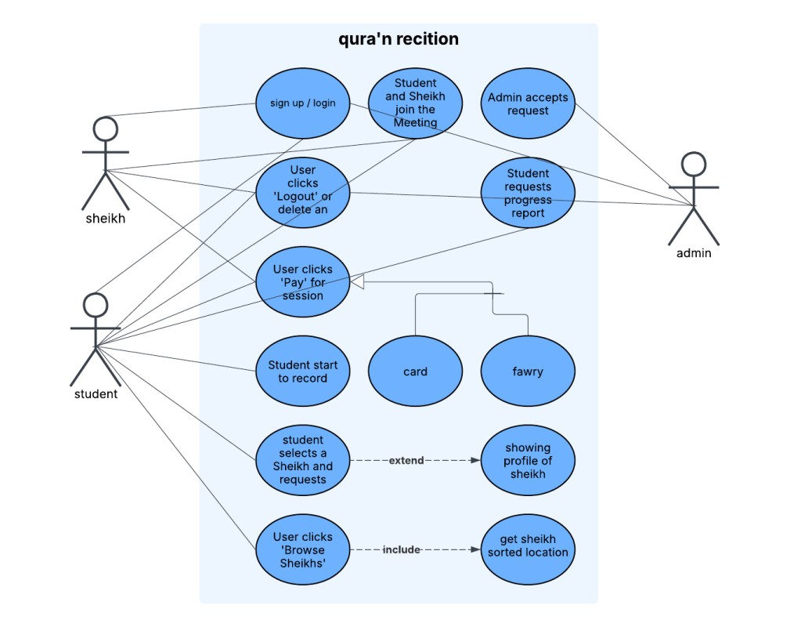

3.4. 3
ACTIVITIES Diagrams :

3.4.3.1 login and sign up
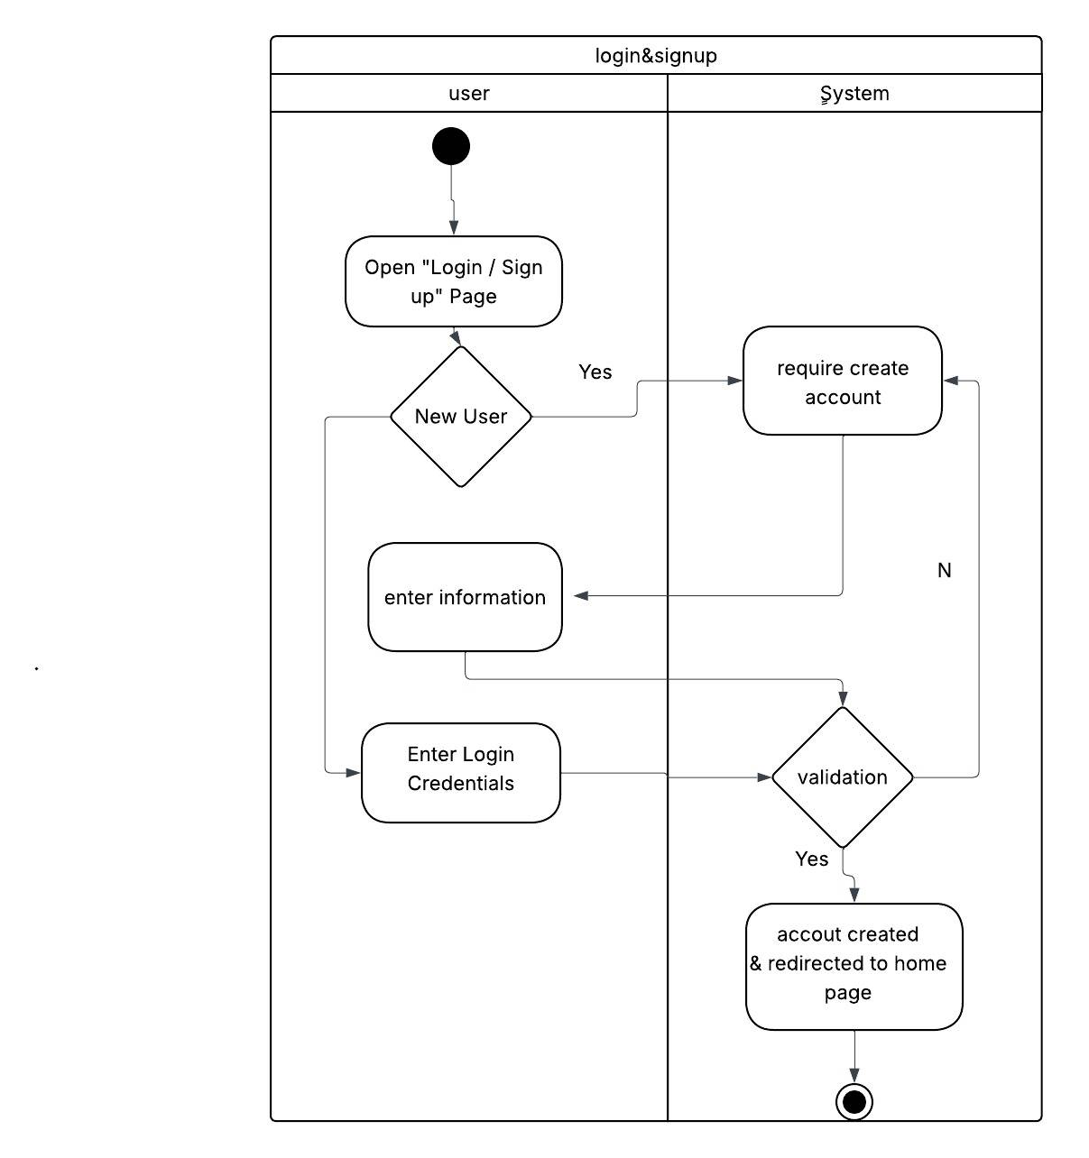
3.4.3.2 admin approval sheikh 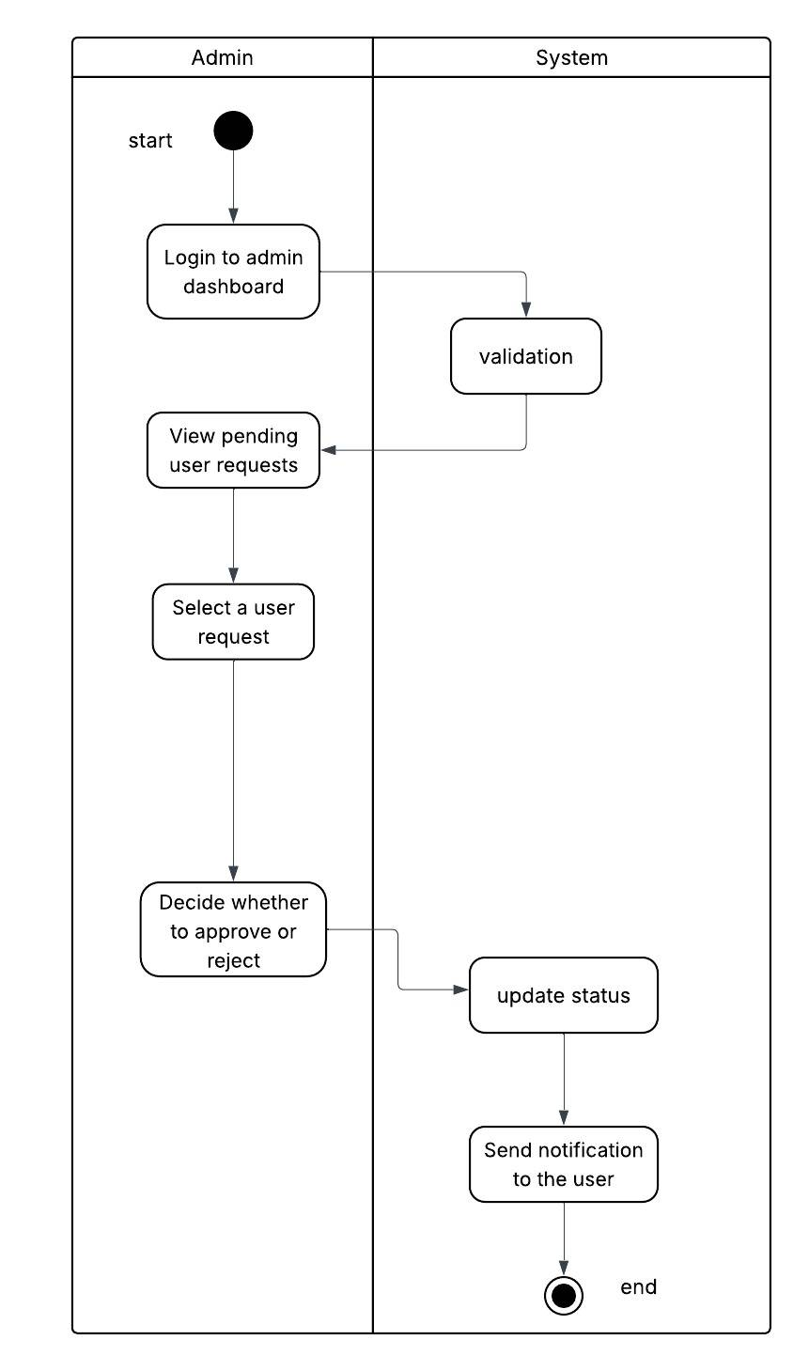
3.4.3.3 browse sheikhs 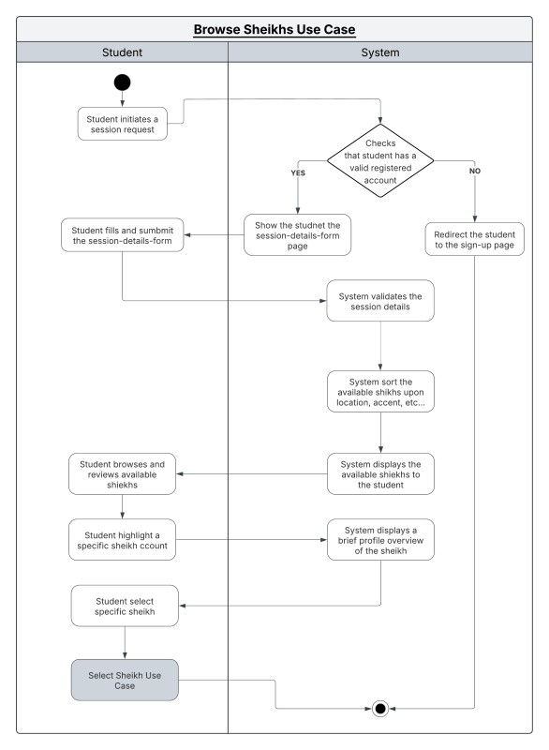

3.4.3.4 select sheikh and start session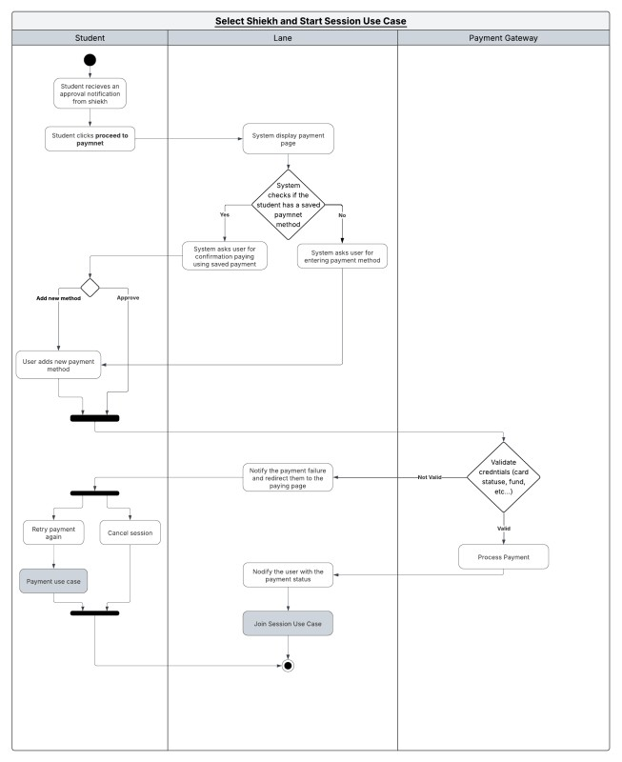

3.4.3.6 sheikh and student join meeting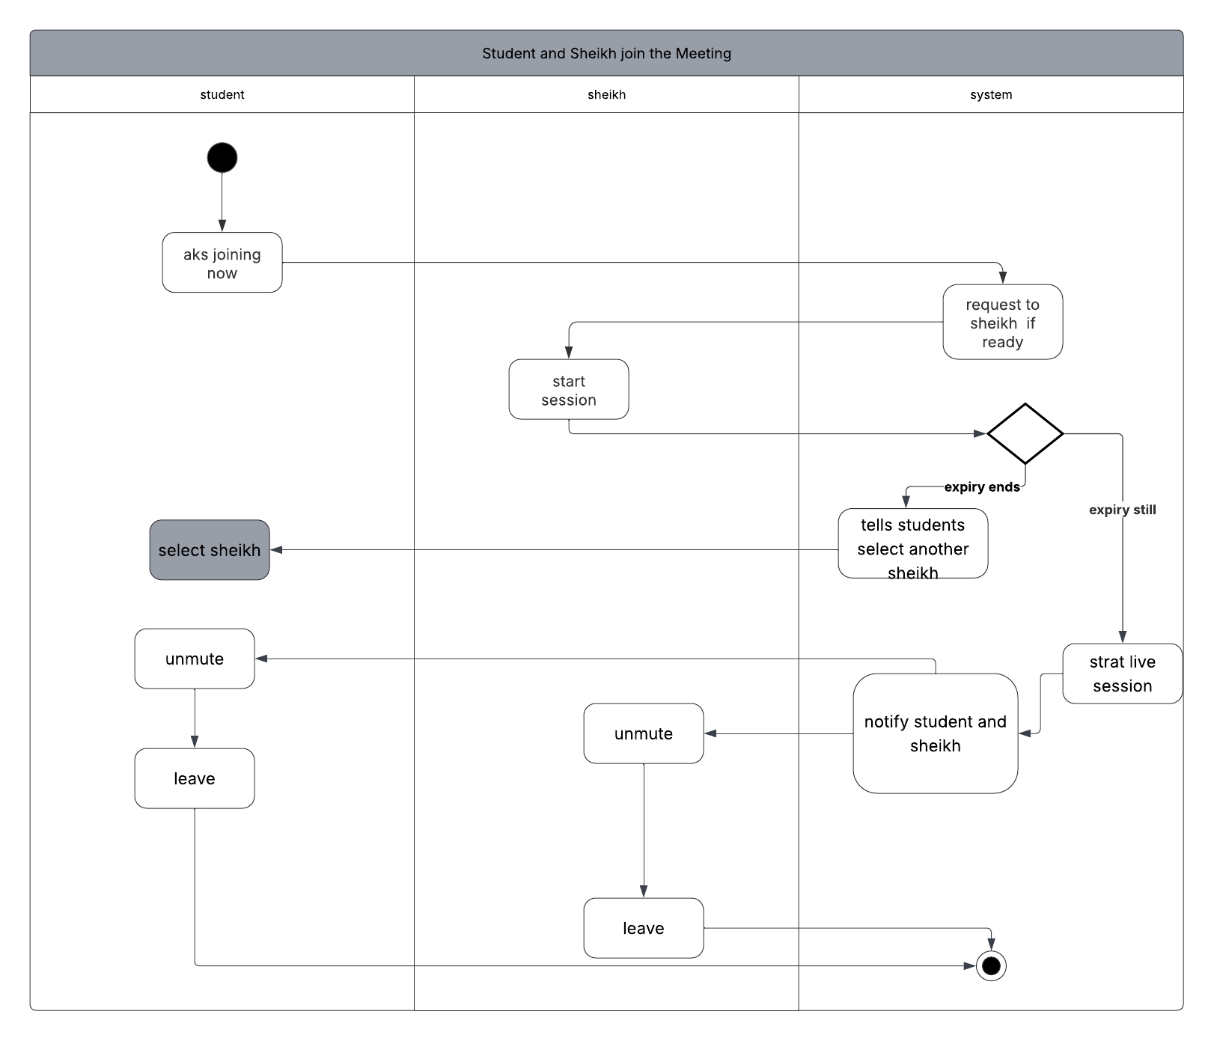

3.4.3.7 sheikh and student join 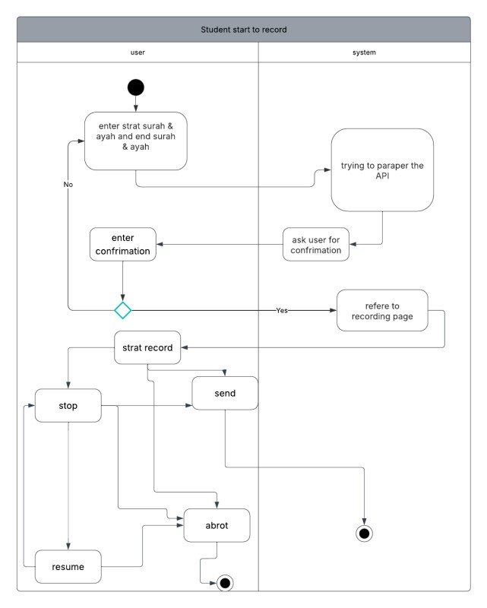

3.4.3.7 sheikh and student join
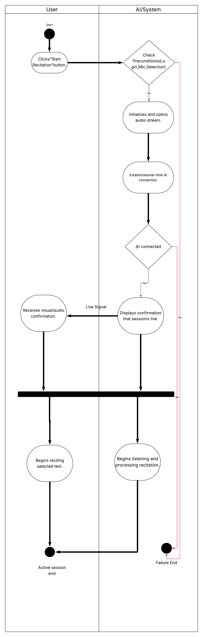
3.4.3.9 user logout or delete account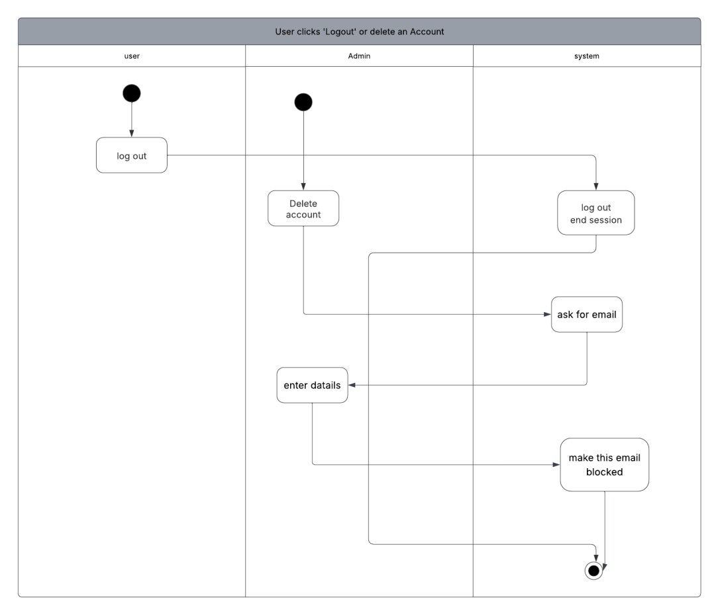

3.4.4.1 use case description payment
Field | Description
Use Case Name | Student Pays for a session
Triggering Event | - The shiekh approves the student’s session request, and the system prompts the student to proceed with payment
Actors | - Student  - Payment Gateway
Pre-Conditions | - A session request must exist and be approved by the Sheikh.  - System must have a configured and available payment gateway.  - Student has access to a valid payment method.
Post-Conditions | Succeful Outcomes:  - Payment is processed successfully.  - Session becomes confirmed.  - Both student and Sheikh receive confirmation notifications.  Unsuccessful Outcome:  - Payment fails, and the session remains pending payment.  - Student may retry payment.
Flow of Activities | Student | System
Flow of Activities | - Student opens the session approval notification.  - Student chooses payment method (card, wallet, etc.).Student wiats for a respons  - Student enters payment details and confirms payment.  - Payment Succeeds.  - Payment fails. | 1.1System displays the payment page with session details and amount.  2.1 System redirects securely to the payment gateway.  3.1 Payment gateway validates card/wallet details.  3.2 Payment gateway returns a success/failure response.  4.1 System marks session as Confirmed.  4.2 System sends confirmation notifications to student and Sheikh.  4.3 System stores the payment transaction securely.  5.1 System displays failure message and retry option.
Exception Conditions | 2.0 Payment gateway timeout/unavailable.  3.0 Payment declined (insufficient funds, card invalid).  3.1 Student cancels payment midway.

3.4.4.2 use case description Browse shiekhs

Field | Description
Use Case Name | Student Browses a Sheikh
Triggering Event | - The student initiates a request to book a Quran recitation session.  - The student enters the required session details (e.g., duration, date, recitation level).
Actors | - Student
Pre-Conditions | - The student must have a valid registered account.  - The system has stored Sheikh profiles with availability, location, and accent information.
Post-Conditions | - A list of available Sheikhs is displayed to the student.
Flow of Activities | Student | System
Flow of Activities | - Student initiates a session request  - Student reviews the available Sheikhs. | 1.1 System Displays the session information form.  - System displays a brief profile preview of the currently highlighted Sheikh.  2.2 System waits for the student’s selection.
Exception Conditions | 1.0 Student does not have an account or is not logged in.  2.0 No available Sheikhs meet the criteria.  2.1 System informs the student: “No sheikhs currently available for your criteria.”  2.2 System fails to correctly sort or retrieve Sheikh data due to internal error.

3.4.4.3 use case description select sheikh

Field | Description
Use Case Name | Student Selects a Sheikh and Requests a session
Triggering Event | - Student selects a Sheikh from the Browse screen and clicks “Request Session”.
Actors | - Student  - Sheikh
Pre-Conditions | - Student has already viewed Sheikhs (Use Case 3 completed).  - Student is logged in.  - Sheikh is available for the requested time.
Post-Conditions | - The selected Sheikh is requested for a session.  - The Sheikh receives a notification containing the session details.  - The student will later receive an approval/refusal notification.
Flow of Activities | Student | System
Flow of Activities | - Student fills in required session details  - Student browses and selects a shiekh  - Student wiats for a respons | 1.1 System validates the entered details.  1.2 System checks Sheikh’s availability for selected time.  2.1 System creates session request record.  2.2 System sends notification to the Sheikh.  2.3 System shows confirmation to the student.  3.1 System notifies student of the Sheikh’s approval or refusal when available.
Exception Conditions | 1.0 Student submits incomplete or invalid session details.  2.0 No available Sheikhs meet the criteria.  2.1 System informs the student: “No sheikhs currently available for your criteria.”  2.2 System fails to correctly sort or retrieve Sheikh data due to internal error.  3.0 System displays a general error message and logs the incident.  3.1 Network or server failure during request submission.

3.4.5 State machines
3.4.5.1 sheikh 3.4.5.2 session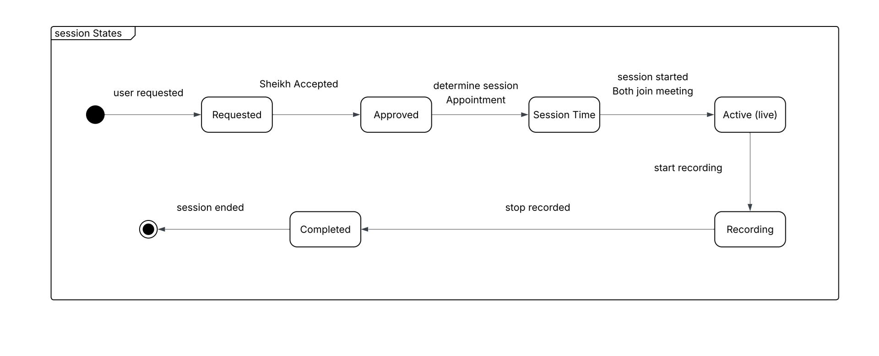

3.4.5.3 record
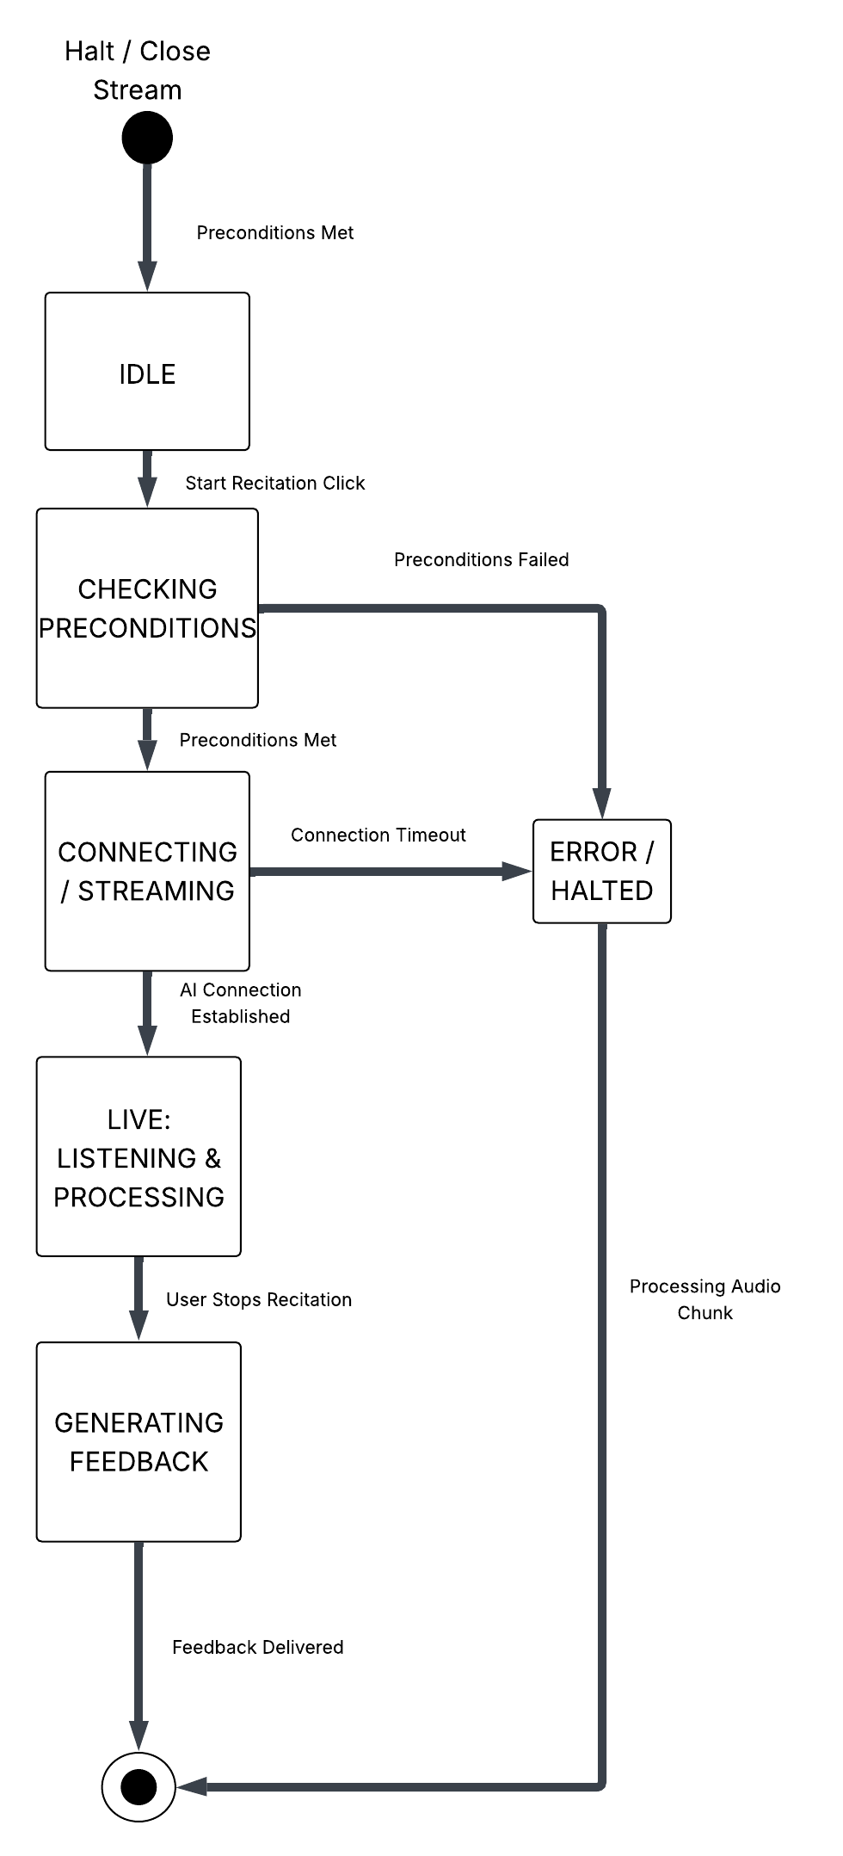
3.4.5.4 payment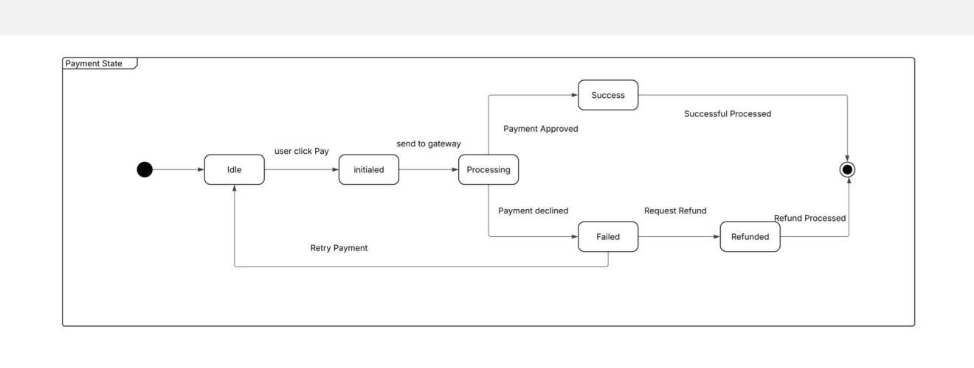
3.4.6
Sequence diagrams
3.4.6.1 sequence admin
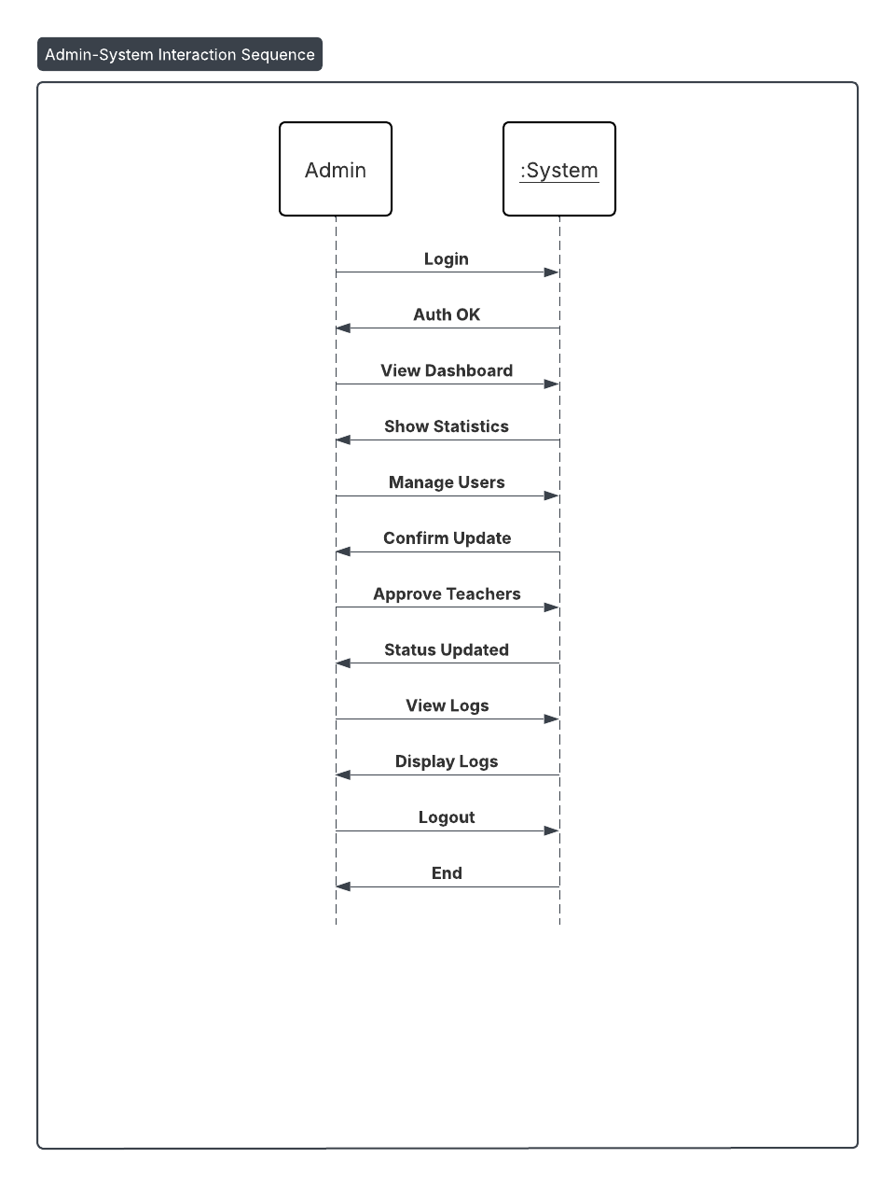

3.4.6.2 sequence student
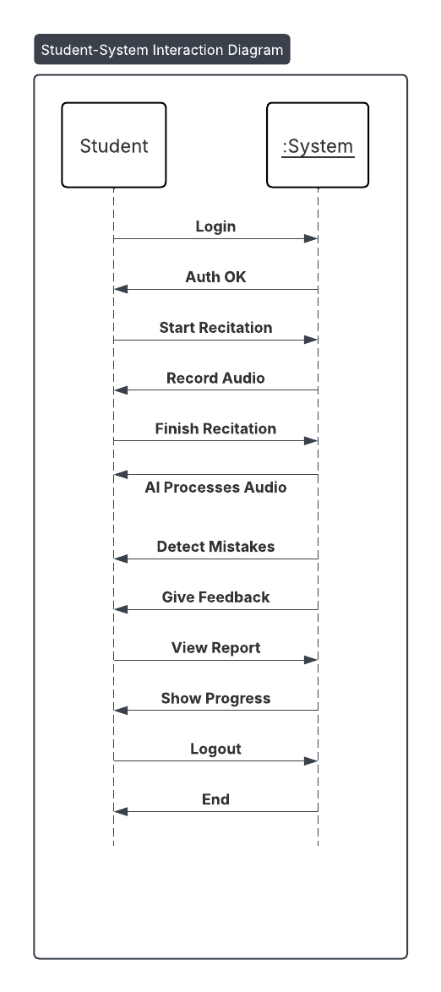

3.4.6.3 sequence sheikh
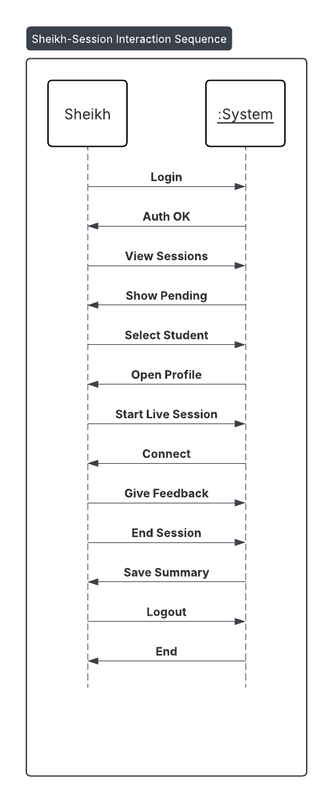

3.4.7 Data flow Diagrams
3.4.7.1
DFD level 0
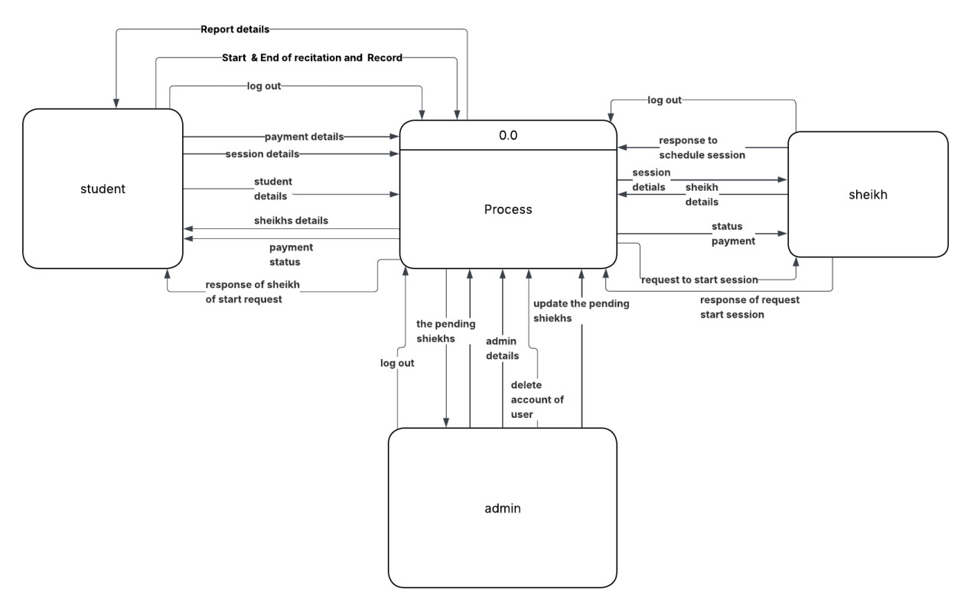

3.4.7.2 DFD LEVEL 1
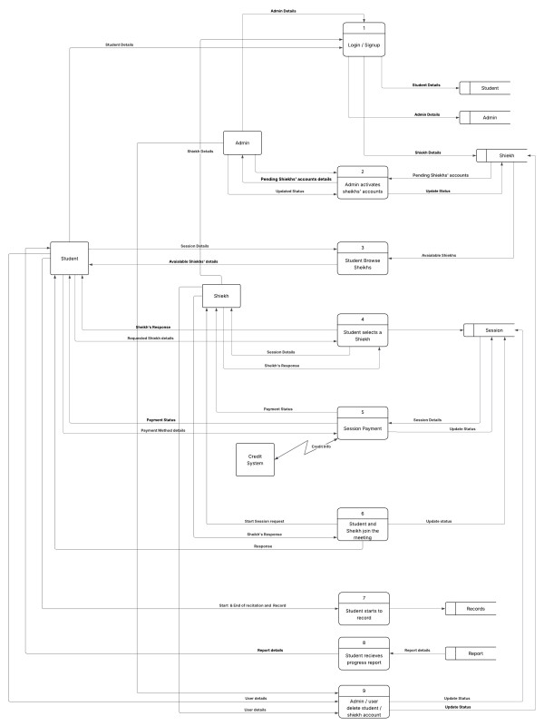

3.4.7.3 level 2
3.4.7.3.1
Level 2 DFD admin activate
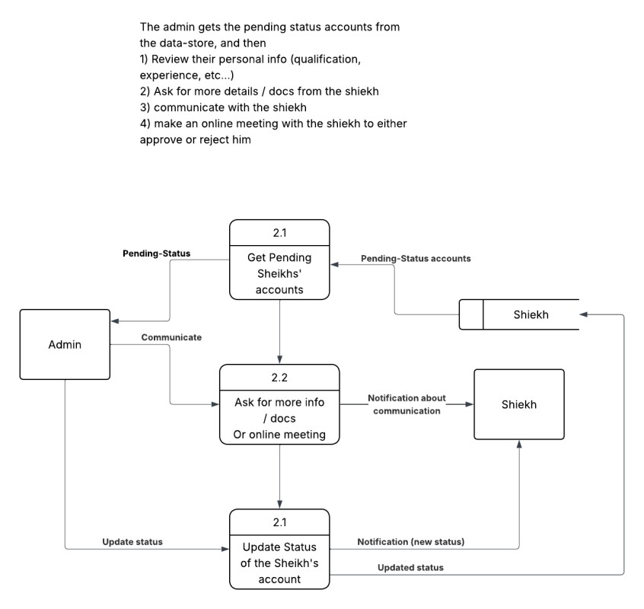

3.4.7.3.2
Level 2 DFD browse the sheikh
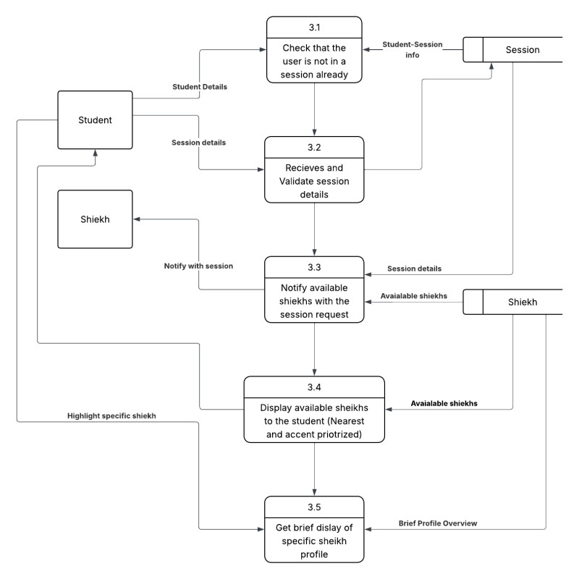

3.4.7.3.3 level 2 DFD select sheikh
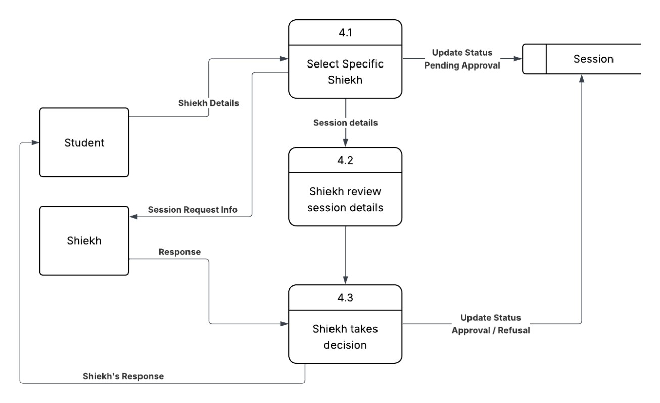
3.4.7.3.4 level 2 dfd student and sheikh 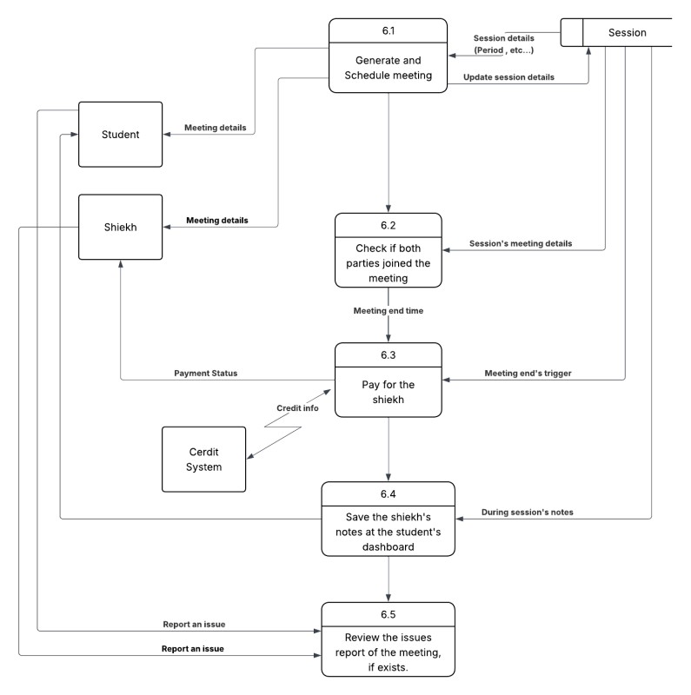

3.4.7.3.5 level 2 dfd payment
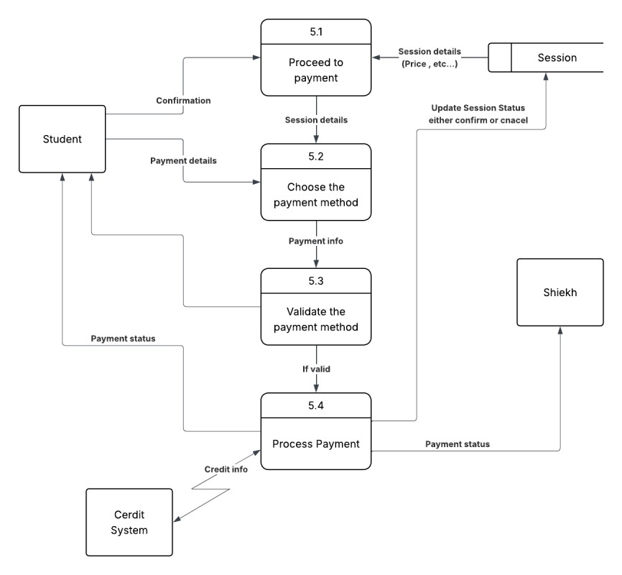

3.4.7.3.6 level dfd 2 AI report
